TITLE: TO FIND FINITE INTEGRATION OF A FUNCTION
USING NEWTON COTES’S FORMULA

Definition:
The Newton-Cotes formula is a numerical integration method that approximates the integral of a function by evaluating the function at equally spaced points and fitting a polynomial through these points to estimate the area under the curve.
Algorithm for Newton Cotes Formula:
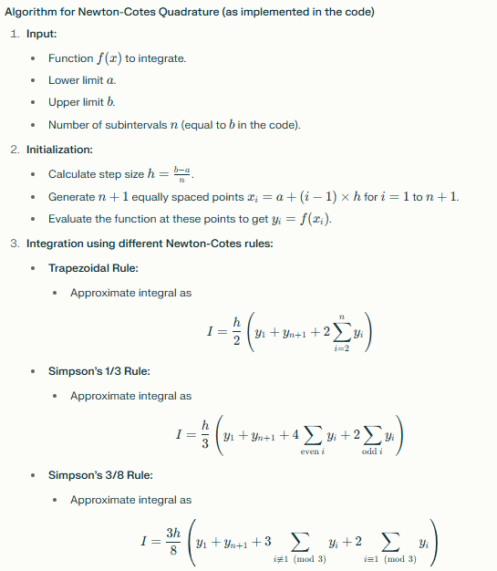
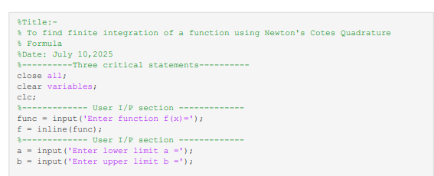
Code:

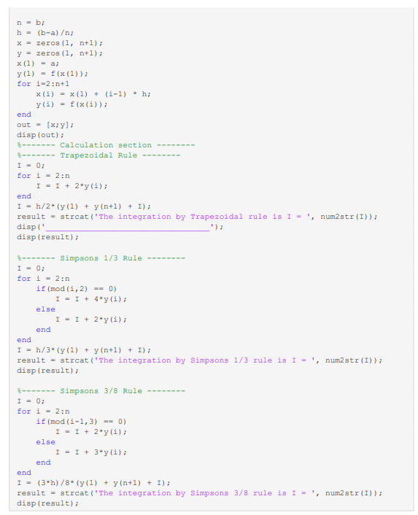

Output:
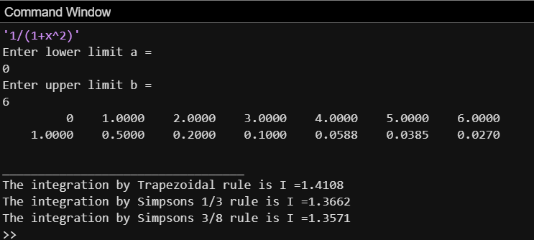
Conclusion:
Newton-Cotes formulas allow us to numerically estimate definite integrals by evaluating the function at equally spaced points and applying polynomial-based rules. This practical demonstrates their effectiveness for approximating finite integrals when exact solutions are difficult.

